***Setting the bar for in-house counsel to learn, connect, serve and grow.***

January 4, 2023

Dear FirstName:

We want to make you aware that your Association of Corporate Counsel (ACC) membership recently expired. To ensure your continued access to the valuable resources that ACC and the ACC Chicago Chapter offer, please consider renewing your membership.

**Simply renew your membership online** [**HERE**](https://www.acc.com/membership/renew-your-membership)**, or call the ACC Membership Department at 202-293-4103, x 360. If you have any questions, please e-mail ACC at** [**membership@acc.com**](mailto:membership@acc.com)**.**

If you are in-transition, ACC will waive your membership dues for up to one year while you search for a new position. Click [HERE](https://www.acc.com/membership/become-a-member/in-transition-member) for more details.

By renewing your ACC membership, you will be able to stay connected with the in-house community and take advantage of:

* [Free CLE programs](https://www.acc.com/chapters-networks/chapters/chicago/events)
* [The ACC Chicago Summit](https://www.acc.com/chapters-networks/chapters/chicago/acc-chicago-summit)
* [Networking Opportunities](https://www.acc.com/chapters-networks/chapters/chicago/events) including our [Celebration Event](https://www.acc.com/chapters-networks/chapters/chicago/annual-house-counsel-celebration-event)
* Access to useful [legal resources](http://www.acc.com/legalresources/index.cfm) such as the[ACC Contracts Portal,](https://www.acc.com/resources?search_api_fulltext=&startdate=1%2F1%2F2015&enddate=12%2F31%2F2020&sort_by=search_api_relevance&sort_order=DESC&field_material_type%5B1426%5D=1426) where you can download and customize model contracts, run draft language through a benchmark tool and view thousands of sample clauses.
* Community Outreach events and other opportunities to serve [Pro Bono](https://www.acc.com/chapters-networks/chapters/chicago/pro-bono-community-outreach) [Street Law](https://www.acc.com/chapters-networks/chapters/chicago/street-law?Site=ACC) [Diversity Summer Internship Program](https://www.acc.com/chapters-networks/chapters/chicago/diversity-summer-internship-program)

**[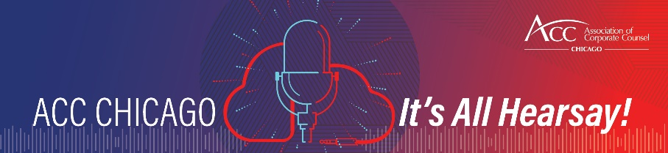](https://www.acc.com/chapters-networks/chapters/chicago/podcast-its-all-hearsay)**

Join us for the ACC Chicago Podcast called, *ACC Chicago: It’s All Hearsay!* To find out how to listen on your favorite platform, clink [here](https://www.acc.com/chapters-networks/chapters/chicago/podcast-its-all-hearsay).

The Officers and Board Members of the Chapter can be found [here](https://www.acc.com/chapters-networks/chapters/chicago/chapter-leadership). Each member of our leadership team encourages you to reach out to us directly. If you choose to attend an event and even volunteer on a committee, you’ll find that the relationships you form can be very valuable. [Lisa Carreras](mailto:Chicago@accglobal.com), our Executive Administrator can also direct you to the best resource. We are all here to serve you and help make the most of your experience.

ACC Chicago has many exciting programs lined up for this year, and we would love you to be a part of it. We look forward to reconnecting with you.

Sincerely,

Char Dalton, President

ACC Chicago

**](https://www.instagram.com/accchicago/)**

Make sure you connect with us on social media to stay current on events and other resources we share. Feel free to like, share and comment.