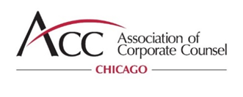
Setting the bar for in-house counsel to learn, connect, serve and grow.

January 4, 2023

Dear FirstName:

As the President of the ACC Chicago Chapter (“ACC Chicago”), I would like you personally welcome you to our in-house community! As a member of ACC, you have access to both ACC global information, resources, and contacts as well as programming and events offered by the Chapter.

ACC Chicago is one of the largest, most progressive and successful chapters within ACC. We have over 2,200 in-house counsel members who represent virtually every leading local, national and international company in Chicago and the surrounding areas… and we continue to grow! We serve the professional needs and interests of the in-house counsel community with education, networking, pro bono and other volunteer leadership opportunities.

To make the most of your membership, I strongly encourage you to become involved with the Chapter and take advantage of the valuable resources available to you. Listed below are some of the many benefits and activities the Chapter offers. More information can be found at https://www.acc.com/chicago.

ACC Chicago Activity Highlights

- Accredited CLE Programs – ACC Chicago develops and offers Illinois accredited, top quality CLE programs tailored to the needs of in-house counsel. We hold an all-day CLE event called the Summit – watch for it! You should be receiving invitations through your email.

- Social Events – These social and networking events, designed to help members to get to know their colleagues, include happy hours, roundtable discussions and each year, our Chapter hosts a gala event celebrating in-house counsel. This year we will be extending that event to include a Professional Responsibility accredited Half-Day program.

- Community outreach and Pro Bono Opportunities – These include both our Diversity Summer Internship Program and our well-respected Street Law program, where Chapter members visit high school classrooms and host a day full of hands-on legal workshops for underserved students from the Chicago Public School System and Northwest Suburbs. We also hold other opportunities for you to serve with your colleagues around Chicagoland with community service events.

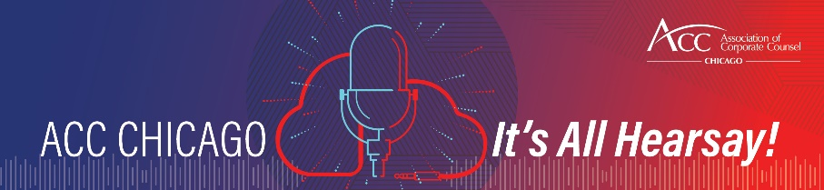
Last year, ACC Chicago launched a Podcast called, ACC Chicago: It’s All Hearsay! To find out how to listen on your favorite platform, clink here.

Make sure you connect with us on social media to stay current on events and other resources we share. Feel free to like, share and comment.



The Officers and Board Members of the Chapter can be found here. Each member of our leadership team encourages you to reach out to us directly if you want to better understand the benefits of your ACC membership or to learn how you can volunteer on a committee or serve as a panelist during one of our events. Our Executive Administrator is Lisa Carreras. She can help you with all things ACC Chicago or direct you to the best resource. We are all here to serve you and help make the most of your experience.

I hope you will find your membership to be rewarding, both professionally and personally. Please don’t hesitate to contact me if you have any questions or would like to be more involved with the Chapter.

Sincerely,
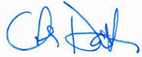
Char Dalton, President
ACC Chicago

