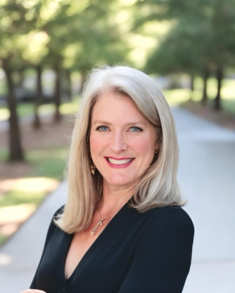
Sonya L Sigler
650-593-8281
info@sonyasigler.com

Lawyer Turned Entrepreneur, Strategic Consultant
Author, Philanthropist, World Traveler
Happily Married Mom of 3 Boys

Sonya L. Sigler is an executive coach, career mentor, and author of two transformative books: WELCOME to the Next Level and What’s Next for My Career? Through her coaching practice, she helps professionals overcome career challenges, identify their true passions, and achieve new levels of personal and professional success. With a background as a lawyer-turned-entrepreneur and experience advising startups, Sonya empowers her clients to navigate career transitions, define their unique value, and build lasting confidence in their professional journeys.
Drawing on the principles from her PractiGal Career Mentor series, Sonya’s coaching focuses on three key areas: setting clear goals, knowing your value, and effectively sharing that value with others. Her approachable and results-driven coaching style helps clients break free from feeling stuck, identify their strengths, and take decisive actions that align with their career aspirations.
Sonya has worked with professionals all over the world at all levels, from early-career individuals to senior executives and business owners, guiding them through significant career milestones such as promotions, transitions to new roles, and even complete career changes. Her experience spans diverse industries, making her a versatile coach for those seeking clarity, growth, and fulfillment in their careers.
Whether you're looking to level up in your current role or explore new opportunities, Sonya offers practical, actionable insights tailored to your unique needs. She believes in empowering her clients to design their own paths, using structured yet flexible strategies that lead to success on their terms.
Books:
WELCOME to the Next Level – Book 1 of the PractiGal Career Mentor Series
What’s Next for My Career? – Book 2 of the PractiGal Career Mentor Series
Set Yourself Up for Success – Book 3 of the PractiGal Career Mentor Series (coming soon)
30 Days to Better Self Care – Book 1 of Your Intentional Life Series

