Information Types Inventory Overview
December 2018
Mark Diamond, CEO & Founder, Contoural, Inc.
Contoural provides information regarding business, compliance and litigation trends and issues for educational and planning purposes. However, legal information is not the same as legal advice – the application of law to an individual or organization's specific circumstances. Contoural and its consultants do not provide legal advice. Readers should consult with competent legal counsel for professional assurance that our information, and any interpretation of it, is appropriate to each reader’s situation.

Information Types Inventory
When developing a records retention schedule or creating a data map, it is often useful to create an inventory of all the types of information in the enterprise. This is called an Information Types Inventory (ITI) and is a working list of record and information types, including departmental inputs on business requirements and document examples. Using a combination of existing documentation and in-person interviews with business functions across the enterprise, record and information types (discrete elements of information that need to be managed and protected) can be collected and confirmed. The inventory process includes identifying (or validating and enhancing existing lists of) information types (including any existing schedule), identifying process outputs, and collecting record type examples during interview sessions (see Figure 2).
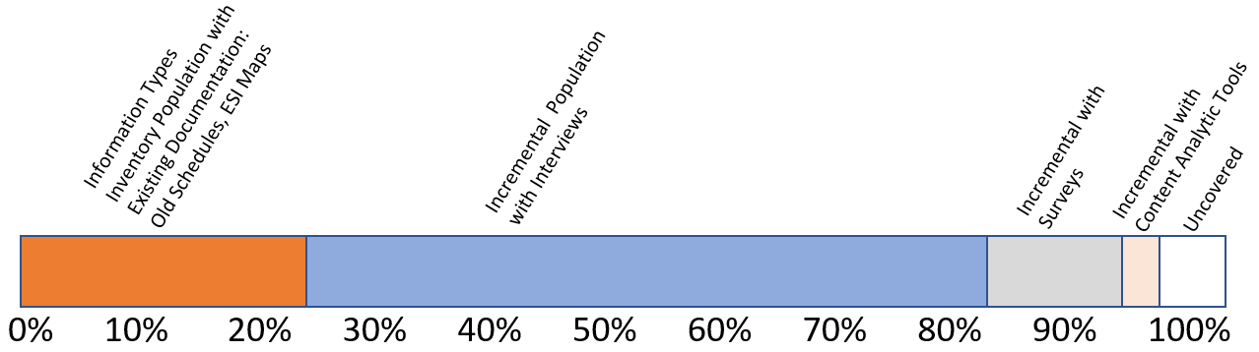
Figure 2. Information Types Inventory Population Strategies - A combination of leveraging existing documentation and interviews can populate a significant portion of the inventory. Interviews are surprisingly effective at collecting this data.
The inventory is then used as a baseline input to the schedule. It sets up the question: From our entire universe of information, which of these should be considered records? The information gleaned during the inventory review can be used to specify recommended retention periods for each unique record class, and, if appropriate, to reflect consolidation of the preliminary record types. The document should include a listing of record classes, which are high-level functional categories, into which record types are grouped and organized for clarity and ease of use, covering all the business records retained by the organization. The schedule should also include selected examples for each record class to enhance end-user understanding of the meaning and scope of each class, as well as updates to associated procedures.
This same inventory used as input into the schedule may also be useful in other areas, including the development of a data security classification policy, eDiscovery ESI map and a privacy policy (see Figure 3). This saves time and reduces the need to ask the business units and employees the same content questions again.
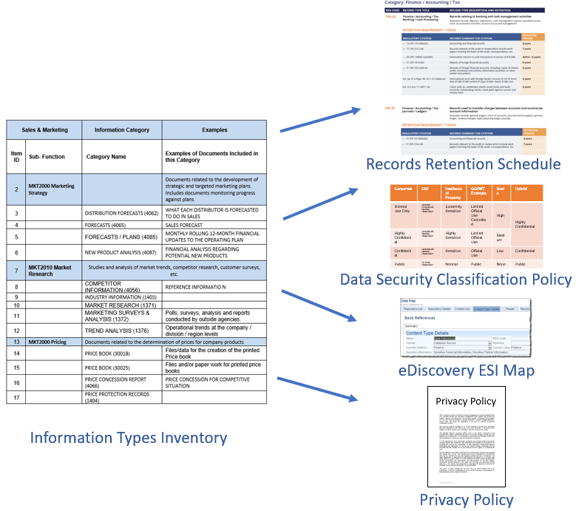
Figure 3. Data collected in an Information Types Inventory can be used not only for schedules, but also data security, discovery and privacy.
Note that we advocate developing a broad Information Types Inventory versus a simpler records inventory. In addition to the previously discussed multiple uses of an inventory, in capturing all the types of information and then classifying those types as records, it is likely the schedule will better capture all the records. In pre-judging what a record is, a records inventory may miss some. Creating a full-blown Information Types Inventory may be a little more work than simply gathering inputs for a records retention schedule, but it is likely to save time in the long run.

Additional Information on This Topic
Webinars:
California Consumer Privacy Act Series Part 2: Creating CCPA Personal Data Inventory, Policies and Controls
The CCPA not only requires businesses to know what consumer privacy information they have where, but also will necessitate adequate data and security controls to protect this information. In this webinar we discuss smart strategies for developing CCPA personal data inventory, policies and controls.
To view the webinar, click here.

Top 5 Reasons an Outdated Records Retention Schedule Can Undermine Your GDPR Compliance
A significant component of the European General Data Protection Regulation (GDPR) will require companies to retain personal data on European residents no longer than is necessary to satisfy the purposes for which it was processed. If your organization does collect and process any personal data, have you justified its retention through your records retention schedule or privacy policies? Companies need an up-to-date records retention policy and schedule to support both deletion and retention of critical information. Join Tom Mighell, Esq., as he discusses the top 5 reasons an outdated retention schedule can undermine your GDPR compliance.
To view the webinar, click here.

Rethinking Email and File Strategies: Making it Easy for Employees to Apply Retention, Security, Collaboration and Disposition
Multiple copies of unstructured data live everywhere -- on desktops, laptops, file shares, removable media, cloud shares, SharePoint, etc.. But before you can organize, you need to first answer some basic questions: Where is the right place for specific content to live? How and where do we keep as few copies as possible? Who can and should have access to what? How do we make it easy to apply both retention and data security, while still enabling classification. In this webinar Greg Forest of Contoural will discuss creating a data placement strategy, making governance frameworks not only easy for employees to follow, but enabling them to be more productive.
To view the webinar, click here.

White Papers:
- Creating a California Consumer Privacy Act Action Plan – Part 1 and 2
Part One provides an overview of CCPA requirements, defines personal information under the new law, compares CCPA requirements to those of the European Union’s General Data Protection Regulation (GDPR), discusses the impact of future updates to the Act, and potential program roadblocks.
Part Two lists the key activities companies must undertake to become compliant, including specific policies, processes, technology and training. Together they provide an efficient, concise and prescriptive plan for ensuring CCPA compliance.
Email Contoural at info@contoural.com for a copy of these white papers

InfoPAK:
Creating a Modern, Compliant and Easier to Execute Records Retention Schedule
In this publication, the details and secrets of excellent record retention programs are unlocked. Learn how to update traditional methods to better fit your modern workplace. Find a starting point, execute an effective and compliant schedule and evolve with new regulations. Available here.

About Contoural
Contoural is the largest independent provider of privacy and Information Governance consulting services. Selling no products nor providing any “reactive” eDiscovery services the company serves as a trusted advisor to more than 30% of the Fortune 500 as well as numerous small and medium-sized enterprises. Contoural is sponsor of ACC’s Information Governance Network as well as sponsor of ACC’s Legal Operations Network Records Management Toolkit. Additional information is available at www.contoural.com.

